Lab Experiments
10.To develop a Deep Q-Network (DQN) for an autonomous drone delivery system to optimize delivery routes under battery
Code:
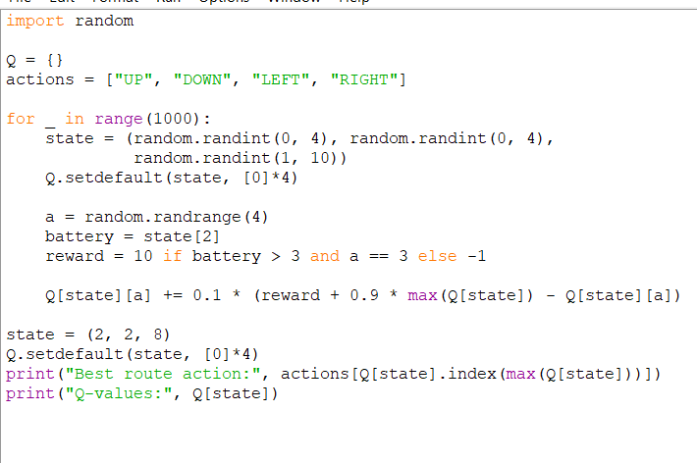
Output:
